## University Of Information Technology And Sciences

##### Submitted To:[Mohammad Mynoddin](https://www.facebook.com/mynoddin?fref=gs&__tn__=,dlC-R-R&eid=ARCuNS6_1wlsC_Es9yRPHjb7BJ8qIpzk2y6Mj6xLbk4YKu58KsxOiRMCbmiLadHmaa1v8gnri0wlce2c&hc_ref=ARRf4Gy6KYo4t7HmirWUybMcVfWx7vW8jJF3pmO1KmvOBrvzPL7wguDejTJFDVorJiY&dti=334048494046664&hc_location=group)

Department Of IT

Submission By:Jhutirmoy Chandra Das

ID:151010400032

Md. Oliullah Shikder Jewel

ID:142010400008

Submission Date:12/5/2018

## Login And Registration Form With Database

## Project Objective:

Creating a login and registration from with database.

## Project Objective:

It will help to secure authentication.

**Feasibility Analysis:**

Requirement Analysis :

1. Simple user interface
2. Intuitive,faster transition time.
3. Full screen run time and touch screen interaction.
4. Retrieve information data from database

Development Environment

1. Windows 7 or above.
2. Java run time environment
3. JDK
4. Android Studio

Design and Development:

Data Flow Diagram:

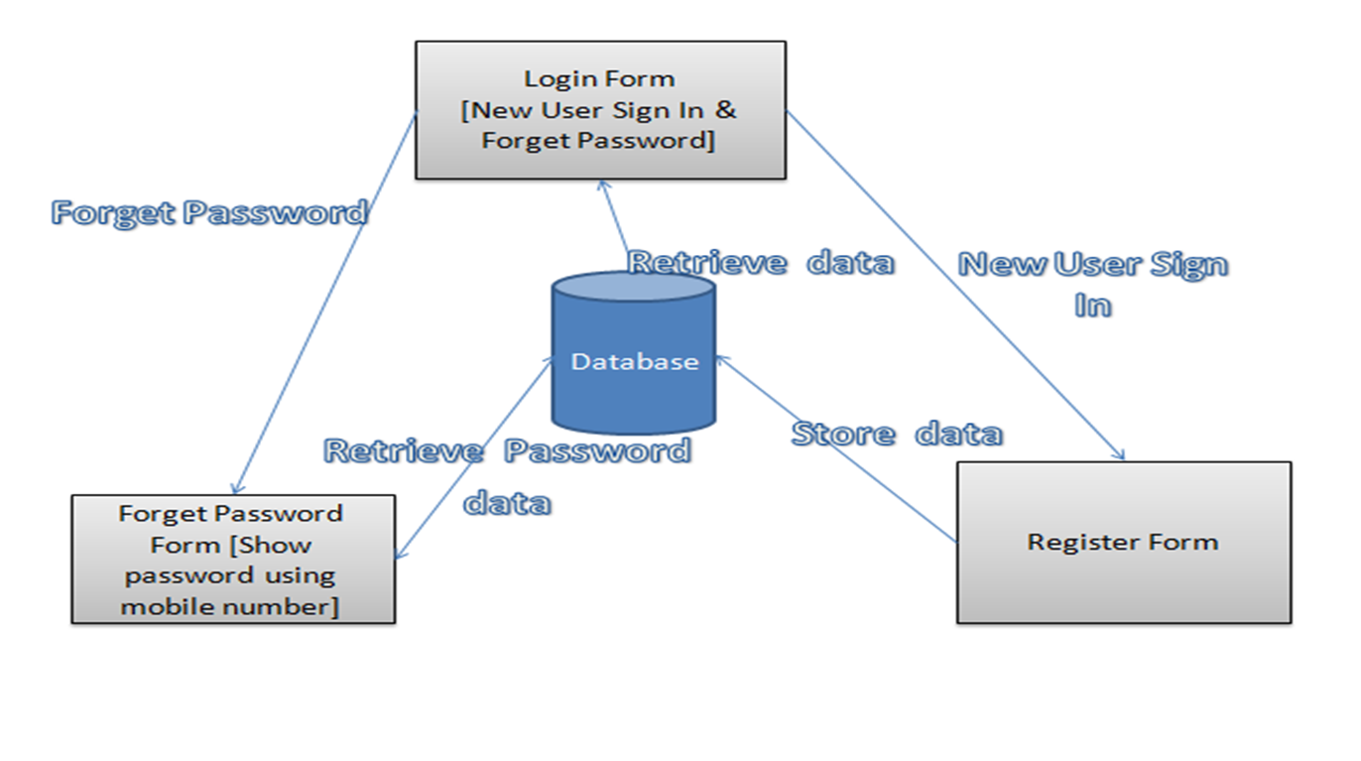

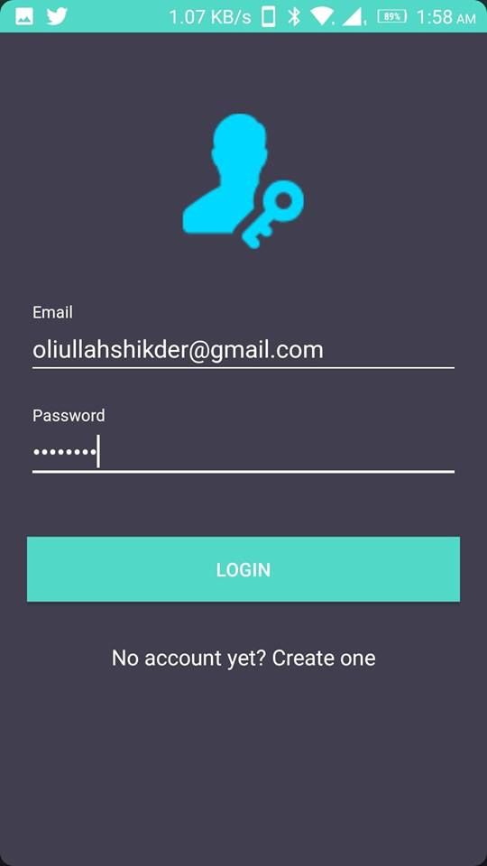

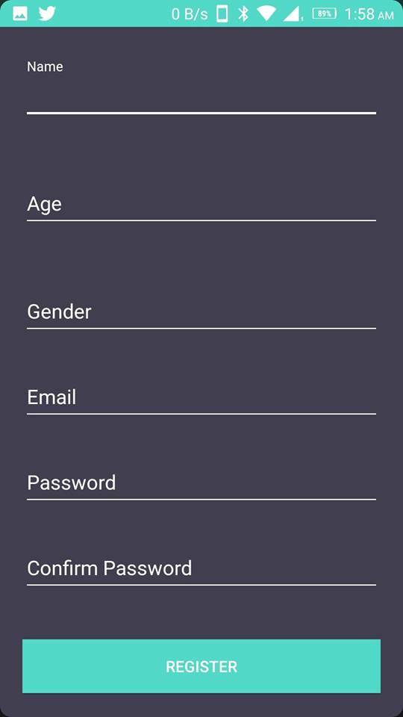

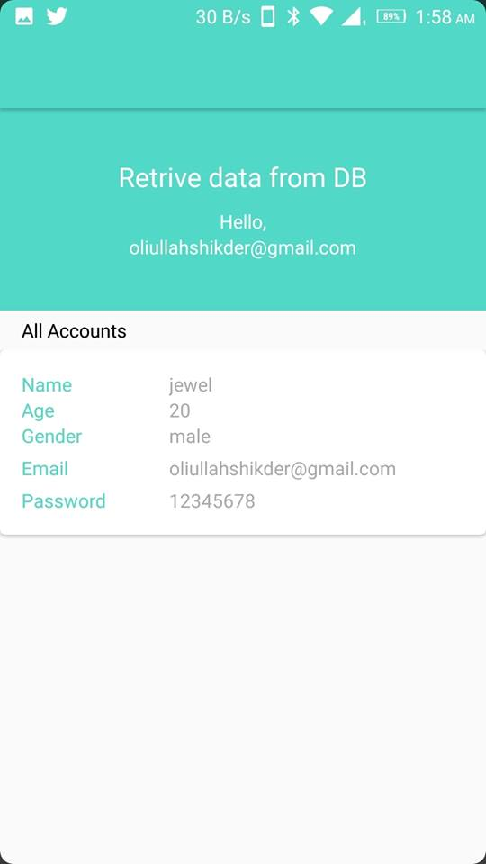

**project source code to github code repository :**